**PRACTICAL 2A**

**AIM:** Use CrypTool to encrypt and decrypt passwords using RC4 algorithm.

**STEPS FOR ENCRYPTION:**

**Step 1:** Open CryptTool🡪File🡪New.

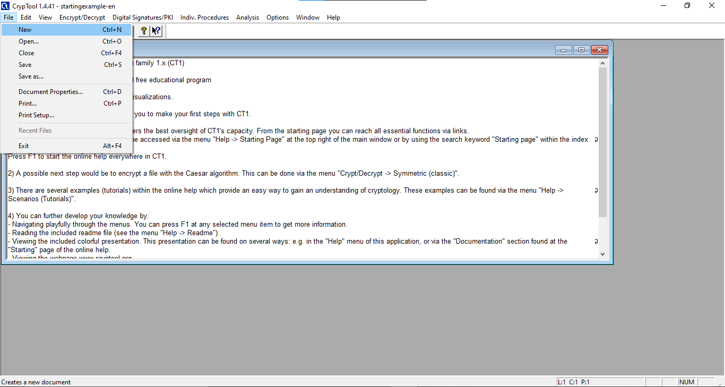

**Step 2:** Enter any text which you want to Encrypt.



**Step 3**: Go to Encrypt/Decrypt🡪Symmetric(modern)🡪RC4.

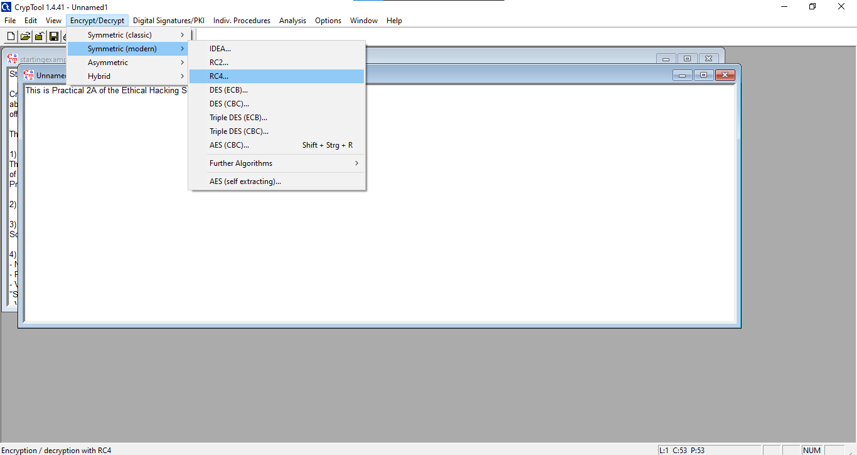

**Step 4:** Select the Key Length as you prefer and click on “Encrypt” Button from the following window.

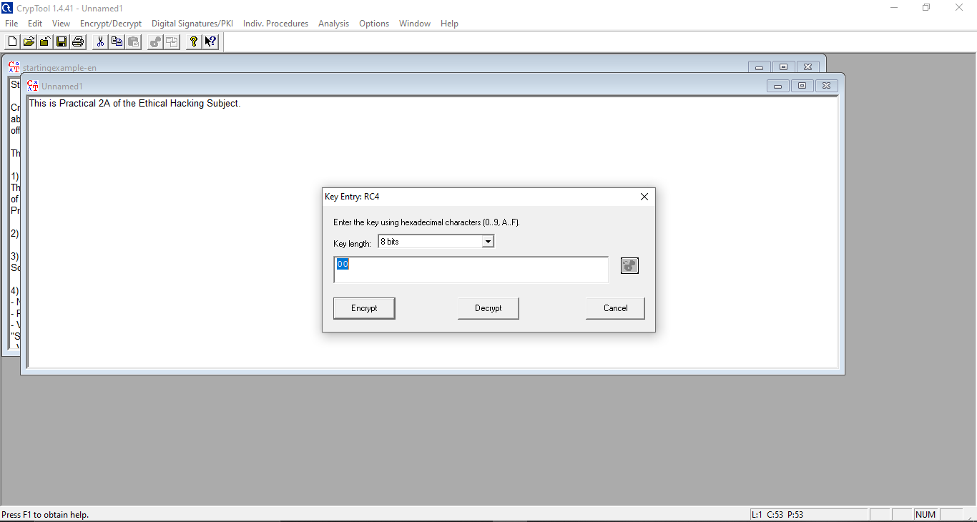

**Step 5:** The Entered Normal Text will get converted into the following Ciphertext.

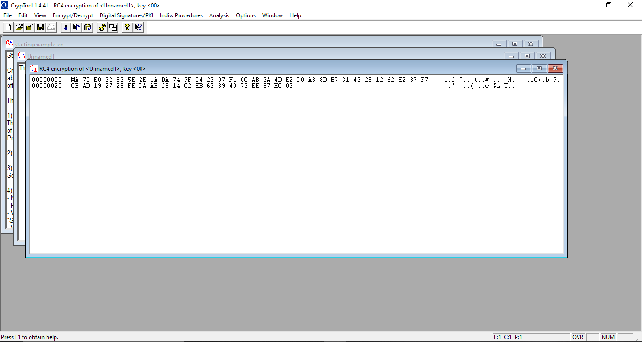

**STEPS FOR DECRYPTION:**

**Step 1**: Go to Encrypt/Decrypt🡪Symmetric(modern)🡪RC4.

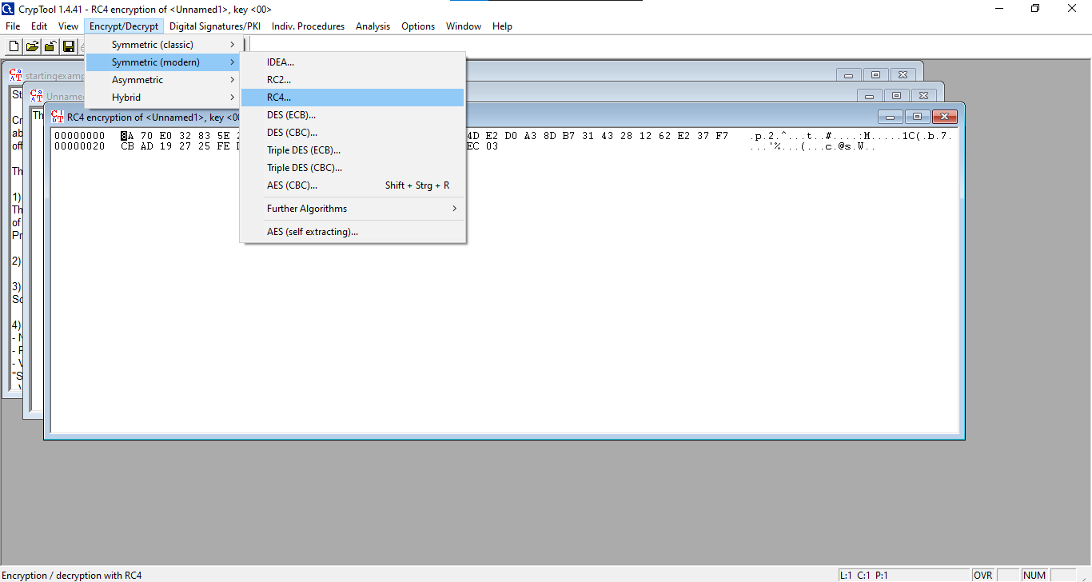

**Step 2:** Select the Key Length as you prefer and click on “Decrypt” Button from the following window.

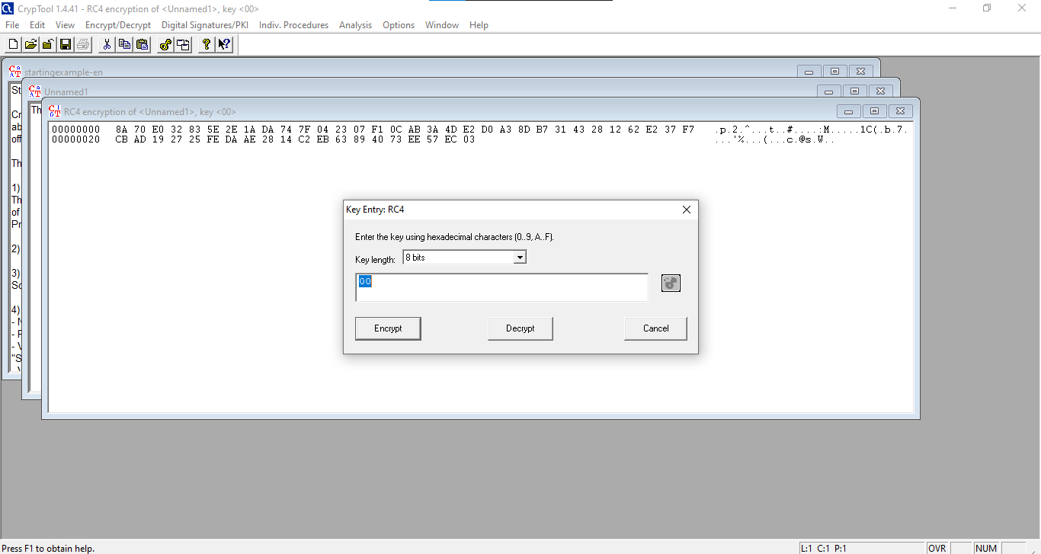

**Step 3:** Following will be the Decrypted Text.

